BAKERY MANAGEMENT SYSTEM

**ABSTRACT**

An Bakery shop that allows users to check for various bakery products available at the online store and purchase online. The project consists of list of bakery products displayed in various categories. The user may browse through these items as per categories. If the user likes a product he may add it to his shopping cart. Once user wishes to checkout he must register on the site first. He can then login using same id password next time. Now he may pay through a credit card or cash on delivery. Once the user makes a successful transaction he gets a copy of the shopping receipt on his email id. Here we use user friendly interface to make the entire frontend. The middle tier or code behind model is designed for fast processing. And SQL serves as a backend to store bakery products lists data. Thus, the online Bakery shopping project brings an entire bakery shop online and makes it easy for both buyer and seller.

**SYSTEM SPECIFICATION**

**Hardware Specification**

Processor : P 4 700 GHz.

RAM : 256MB RAM

Hard Disk Drive : 40 GB HDD

**Software Specification**

Operating System : Windows XP/7/8/10

Front End : JAVA

Back End : MY SQL

**Existing system:**

A manual system sometime may hard to find some difficulties. Which could be show some wrong data and very hard to managing the stores. So we can provide the some automatic system wise bakery management. Which have avoid some drawbacks.

The followings are the drawbacks of existing system

**Disadvantages:**

* Very hard to calculate stock details
* Waste of paper works
* Billing details are manually calculated

**Proposed System:**

This system is easy to managing the bakery shop. We no need to memories any product or purchase details. All can be managed by systematically. It could be very easy and attractive design. Every user can easy to use this system so we no need to study separate study for this project.

**Advantages:**

* Very low cost and high efficiency
* Purchase and sales details are managed systematically.
* Save time

**Modules:**

1. Customer Registration
2. Purchase Orders
3. Sales Orders
4. Billing Report
5. **Customer Registration**

This modules contains add the new customer details. It Includes are User id, name, date of birth, address, mobile number, e-mail id, password and so on.

1. **Purchase Orders:**

This modules contains are user purchase the item details maintained. It includes are item name, purchasing date, no of quantity, rate details and so on.

1. **Sales Order**

This module contains maintain the sales details, with the help of sales details we can generate the billing report. Once the order was purchased by customer the amount will be added to the billing report.

1. **Report:**

This Module Contains two sub Modules. They are a. User Report- user can view their past purchase history and b. Admin Report- Admin can view the user history and purchase history.

**DATA FLOW DIAGRAM**

**LEVEL 0:**

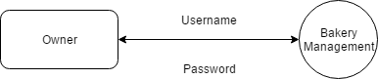

**LEVEL 1:**

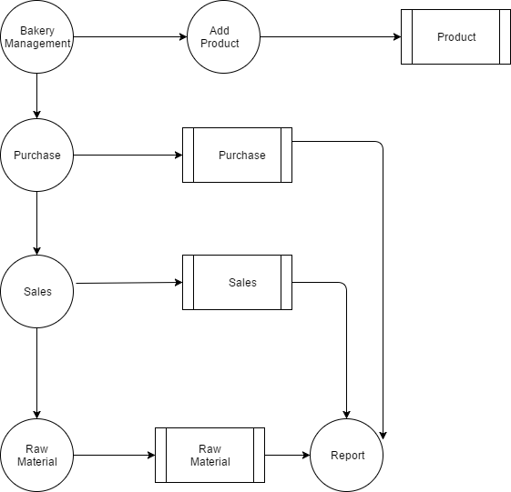

**TABLE DESIGN**

**TABLE NAME : CUSTOMER**

**PRIMARY_KEY : CID**

|  |  |  |  |
| --- | --- | --- | --- |
| **FIELD** | **DATA TYPE** | **SIZE** | **DESCRIPTION** |
| cid | Int |  | Customer id |
| Cname | Varchar | 30 | Customer name |
| Contact | Varchar | 10 | Contact no |
| Caddress | Text |  | Contact address |

**TABLE NAME : PURCHASE**

**PRIMARY_KEY : PID**

|  |  |  |  |
| --- | --- | --- | --- |
| **FIELD** | **DATA TYPE** | **SIZE** | **DESCRIPTION** |
| pid | Int |  | Purchase id |
| Pname | Varchar | 30 | Purchase name |
| Price | Int |  | Purchase amount |
| Date | Date |  | Purchase date |
| Time | Time |  | Purchase time |

**TABLE NAME : SALES**

**PRIMARY_KEY : SID**

|  |  |  |  |
| --- | --- | --- | --- |
| **FIELD** | **DATA TYPE** | **SIZE** | **DESCRIPTION** |
| sid | Int |  | Sales id |
| Sname | Varchar | 30 | Sales name |
| Price | Int |  | Sales amount |
| Date | Date |  | Sales date |
| Time | Time |  | Sales time |

**TABLE NAME : BILLING**

**PRIMARY_KEY : BID**

**FOREIGN KEY : PID,CID**

|  |  |  |  |
| --- | --- | --- | --- |
| **FIELD** | **DATA TYPE** | **SIZE** | **DESCRIPTION** |
| Bid | Int |  | Billing id |
| Pid | Int |  | Purchase id |
| cid | Int |  | Customer id |
| Price | Int |  | Price of product |
| Time | Time |  | Sales time |
| Date | Date |  | Sales date |

**TABLE NAME : RAWMATERIAL**

**PRIMARY_KEY : RID**

**FORGIGN KEY : PID,CID**

|  |  |  |  |
| --- | --- | --- | --- |
| **FIELD** | **DATA TYPE** | **SIZE** | **DESCRIPTION** |
| Rid | Int | 10 | Raw ID |
| Pid | Int | 10 | Purchase id |
| cid | Int | 10 | Customer id |
| Price | Int | 10 | Price of product |
| Time | Time | 10 | Sales time |
| Date | Date | 10 | Sales date |